9.28: a) Combining Equations (9.13) and (9.15),

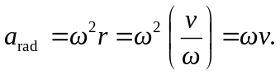
b) From the result of part (a), 